Assignment 3

Q1 Given an integer, n, perform the following conditional actions:

If n is odd, print Weird

If n is even and in the inclusive range of 2 to 5, print Not Weird

If n is even and in the inclusive range of 6 to 20, print Weird

If n is even and greater than 20, print Not Weird

Complete the stub code provided in your editor to print whether or not is weird.

Input Format

a positive integer, .

Output Format

Print Weird if the number is weird; otherwise, print Not Weird.

Sample Input 3

Sample Output Weird

Sample Input 24

Sample Output Not Weird

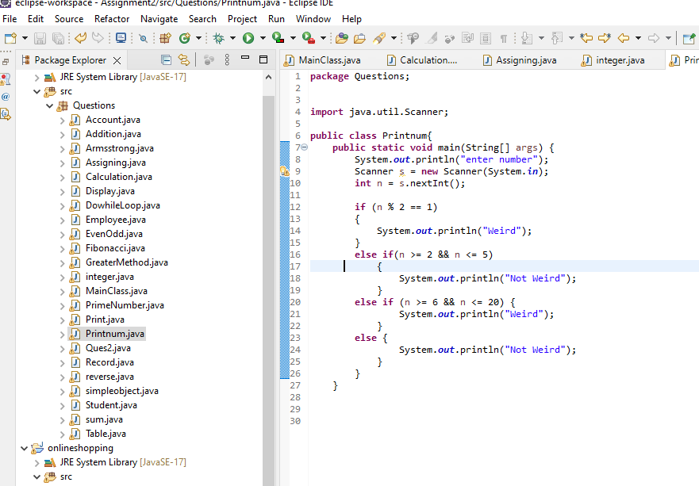

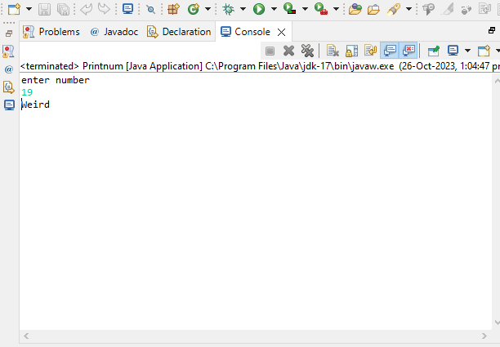

Q 2) create a class three methods

a) void cube(int a)

b) void square (int b)

c) void greater(int a,int b,int c)

create another class having main method

display menu

1) cube

2) square

3) greater

Ask choice from user and based on choice call above methods

Repeat the menu till choice is not equal to 0

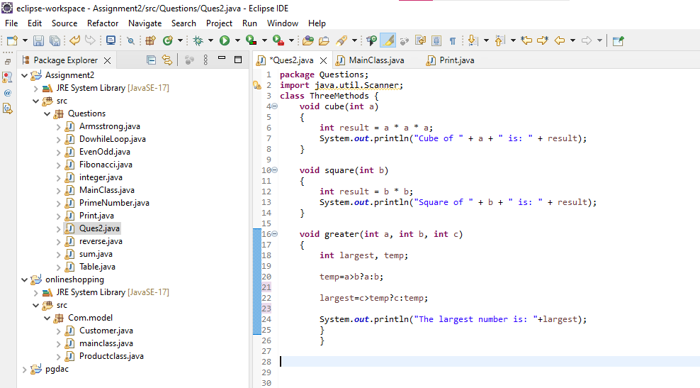

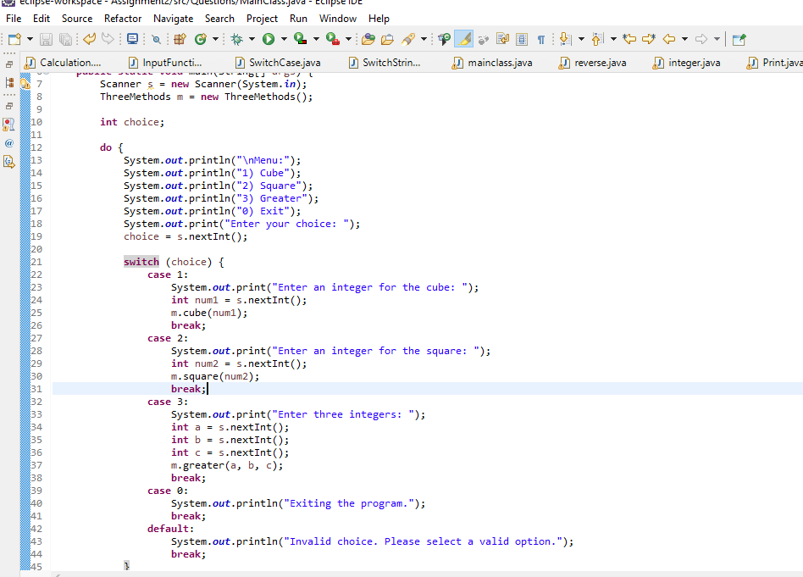

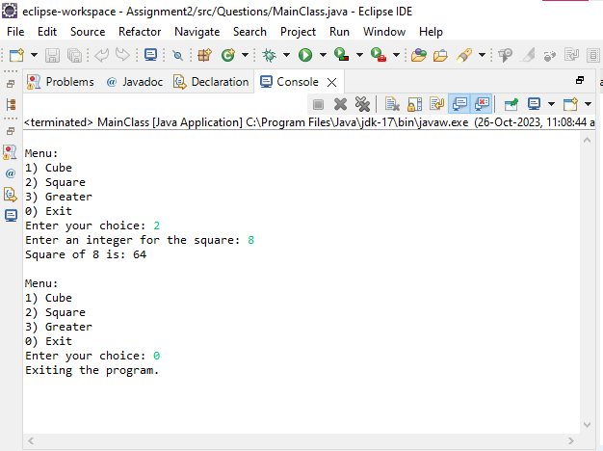

Q 3 create another class having method like

void greater() --> take 3 input within function

void greater(int ,int)

void greater(int a,int b,int c)

create main in same class and call all methods

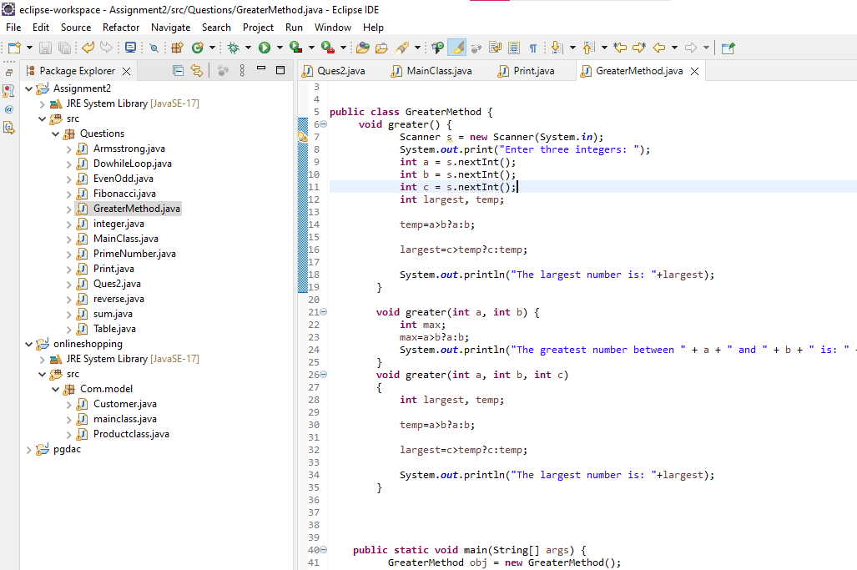

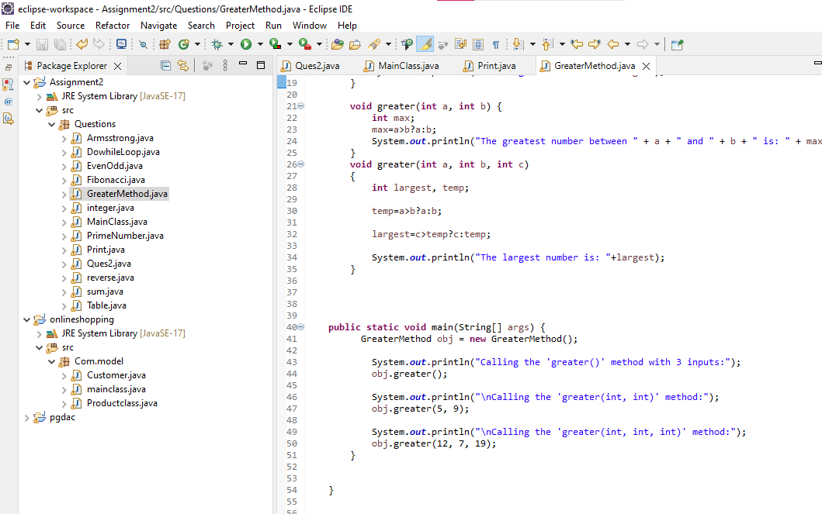

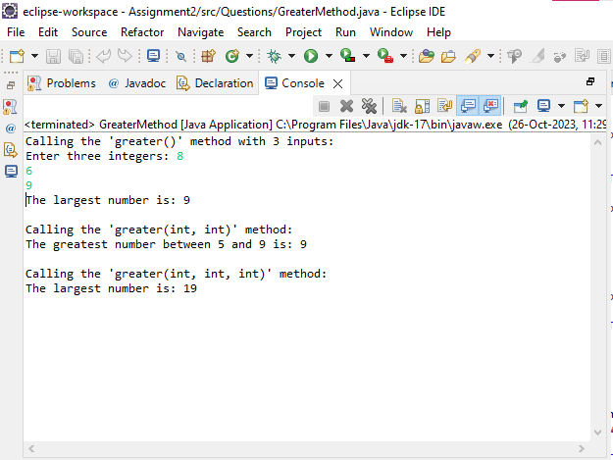

Q4 WAP using parameterized constructor with two parameters id and name. While creating the objects obj1 and obj2

passed two arguments so that this constructor gets invoked after creation of obj1 and obj2

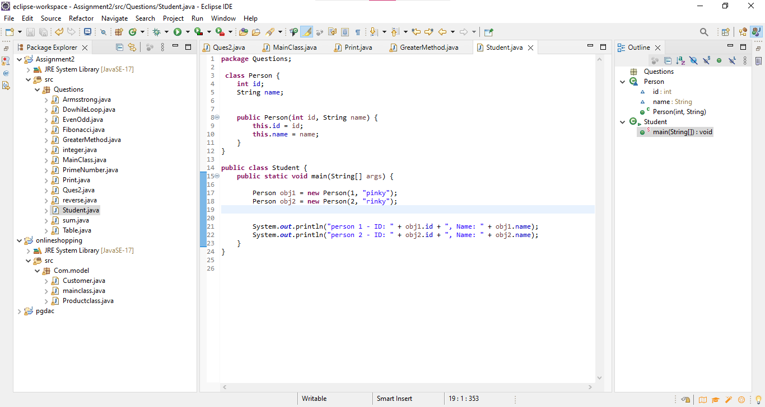

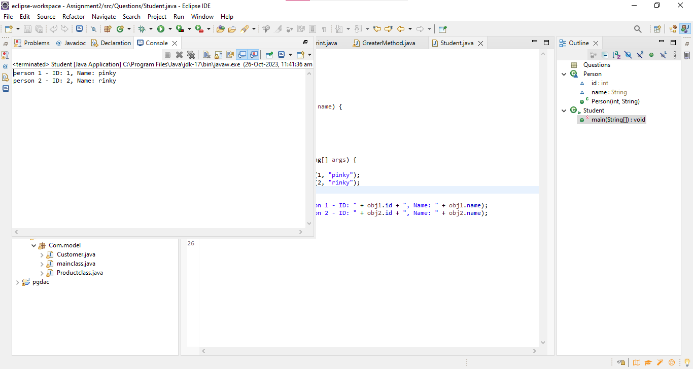

Q 5 Write a program by creating an 'Employee' class having the following methods and print the final salary.

1 - 'getInfo()' which takes the salary, number of hours of work per day of employee as parameter

2 - 'AddSal()' which adds 10000 to salary of the employee if it is less than 50000.

3 - 'AddWork()' which adds 5000 to salary of employee if the number of hours of work per day is more than 6 hours.

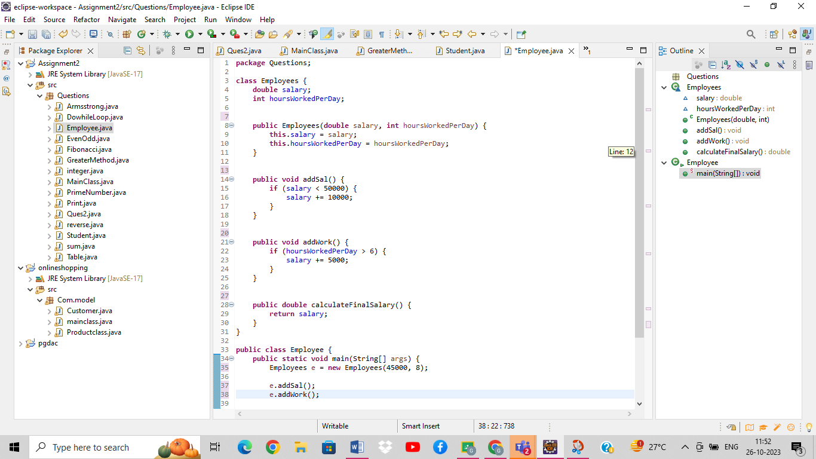

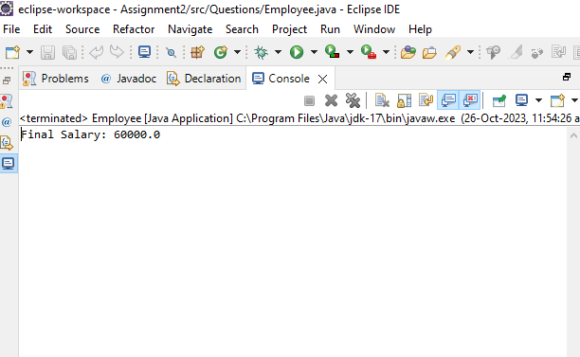

Q 6 Write a program to create a room class, the attributes of this class is roomno, roomtype, roomarea and ACmachine. In this class the member

functions are setdata and displaydata.

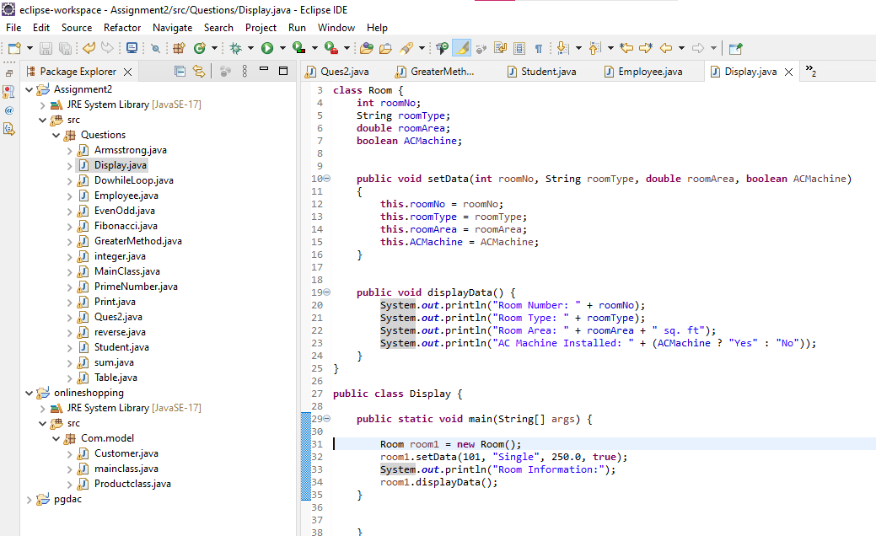

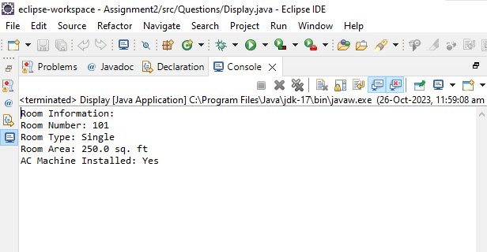

Q7 Write a program create a class ‘simpleobject‘. Using constructor display the message.

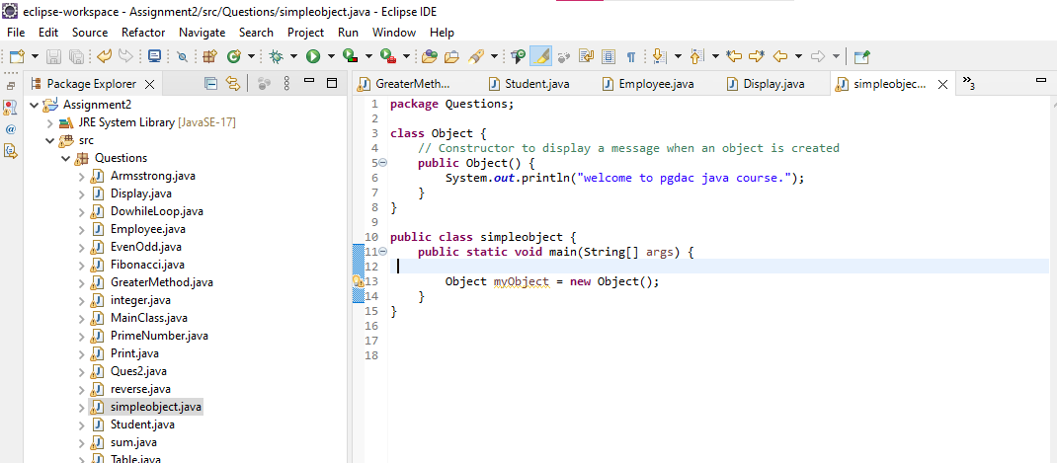

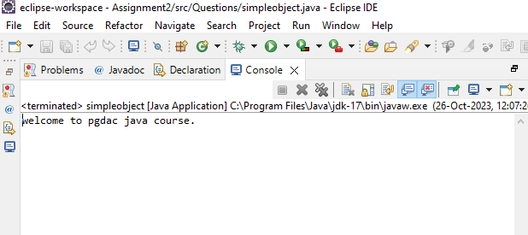

Q 8 Design a class to represent bank account. Include members:

a. Data members

i. Name of depositor

ii. Account number

iii. Type of account

iv. Balance amount

b. Methods

i. To assign value

ii. To deposit amount

iii. To withdraw amount

iv. To display name and balance .

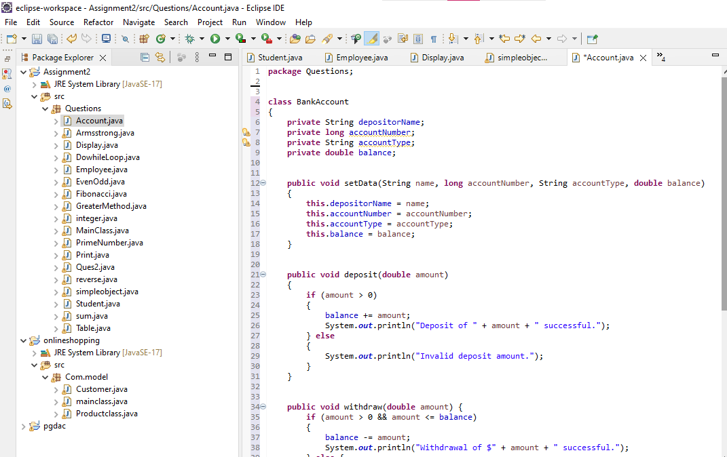

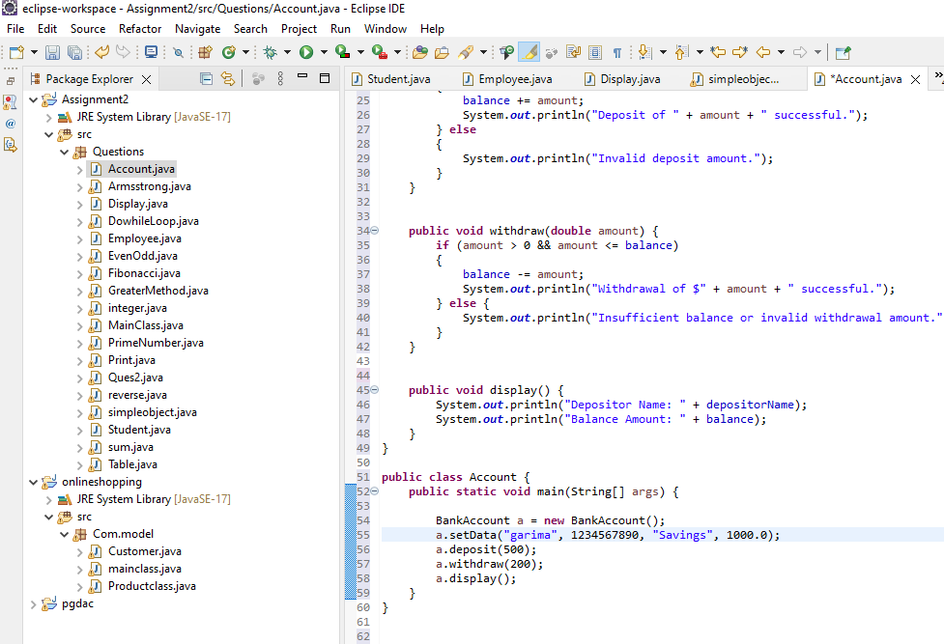

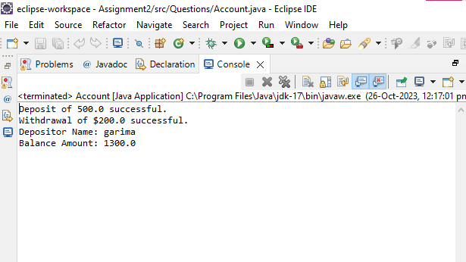

Q 9 Create a class named 'StudentRecord' with String variable 'sname' and integer variable 'roll_no'.

Assign the value of roll_no as '2' and that of name as "John" while creating an object of the class Student.

and using display method show all values on console

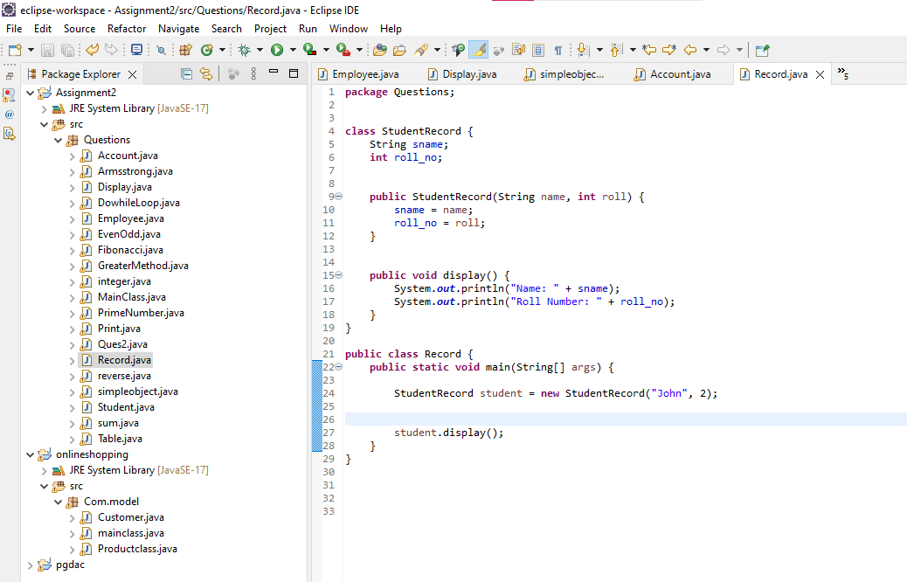

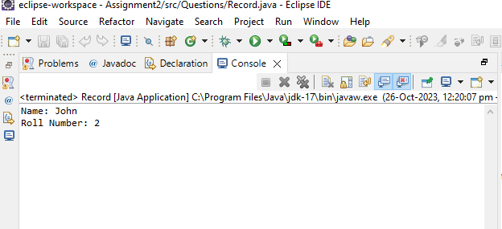

Q 11 wap to perform addition of two three and fourth integer numbers using functions

(use polymorphism)

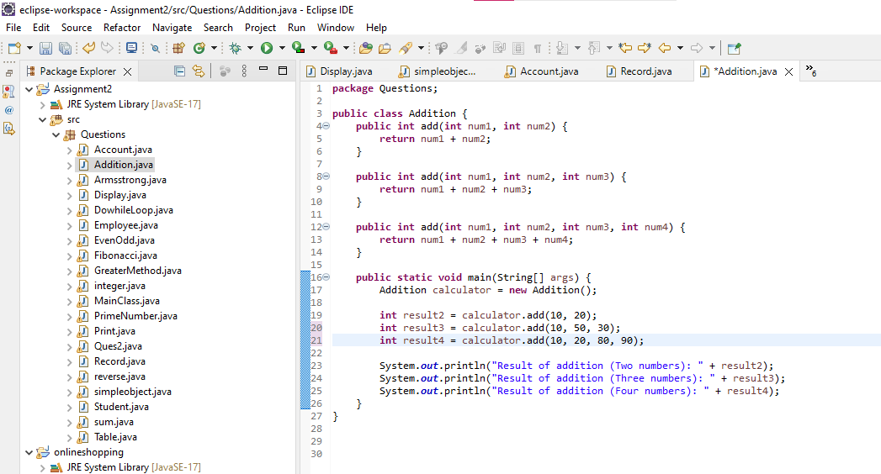

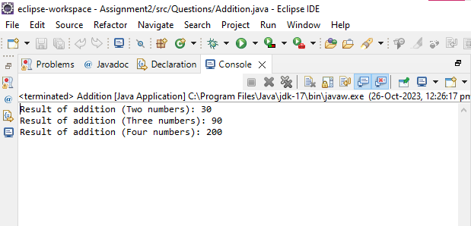

Q 12 Write a JAVA program which contains a method square() such that square(3) returns 9,

square(0.2) returns 0.04.

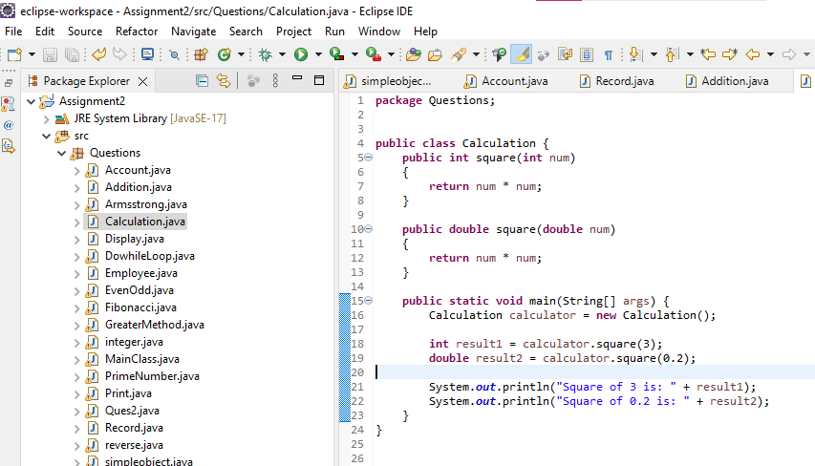

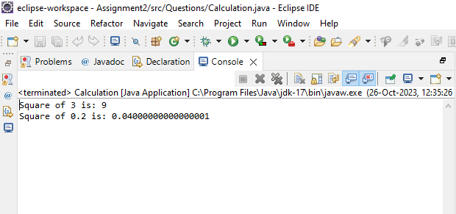

Q 13/* * Design class and declare instance variable of integer type

*

* store value to instance variable during object creation .

*

* in case if we do not pass any value to during object creation then zero will be stored in it

*

* create display method to display instance variable

